Garrett Woods
Module 9.2

Unformatted:
Formatted:
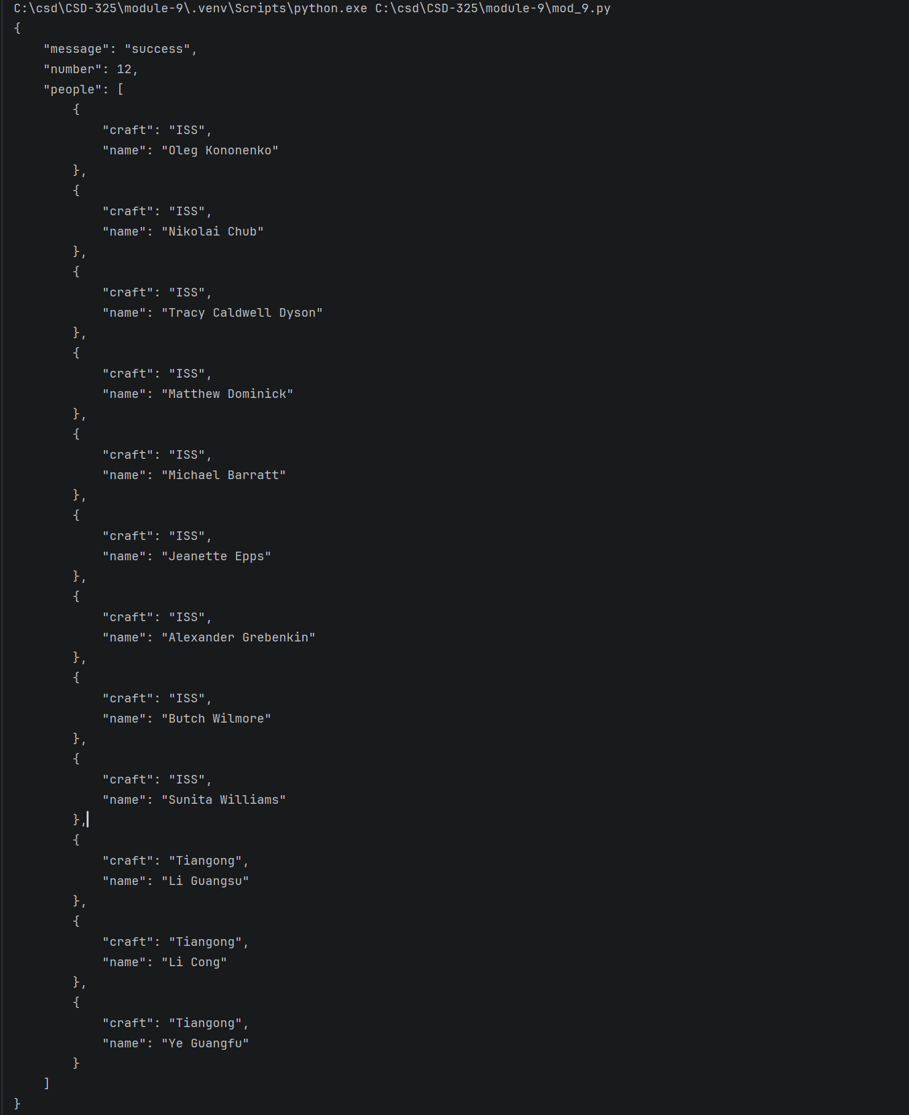

Unformatted:
Formatted:
